**Turtlebot 2**

**3.1 Introduction**

TurtleBot is designed to be easy to buy, build, and assemble, using off the shelf consumer products and parts that easily can be created from standard materials. As an entry level mobile robotics platform, TurtleBot has many of the same capabilities of the company's larger robotics platforms, like PR2, Care-O-Bot. With TurtleBot, users can drive around and map their environment, see in 3D, and have enough horsepower to create their own applications.

With the standard TurtleBot components users can use TurtleBot to do realtime obstacle avoidance and autonomous navigation.

**3.2 Installing Turtlebot2**

Firstly, cd to your catkin workspace.

If you don't have one, cd to somewhere you want to create it, and then run the following commands to create one.



mkdir -p src



catkin_make

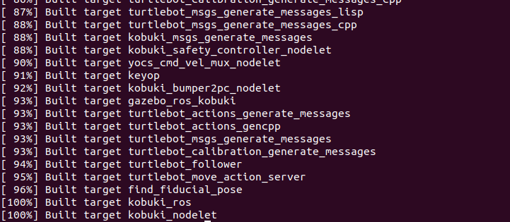

Now run the following command (inside the root of catkin workspace) to build up running environment for Turtlebot2.



curl -sLf https://raw.githubusercontent.com/gaunthan/Turtlebot2-On-Melodic/master/install_basic.sh | bash



catkin_make

Installing dependencies for Melodic

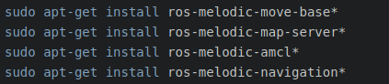

sudo apt-get install ros-melodic-move-base*

sudo apt-get install ros-melodic-map-server*

sudo apt-get install ros-melodic-amcl*

sudo apt-get install ros-melodic-navigation*

**3.3 Testing and running Turtlebot2**



source ./devel/setup.bash

roslaunch turtlebot_stage turtlebot_in_stage.launch

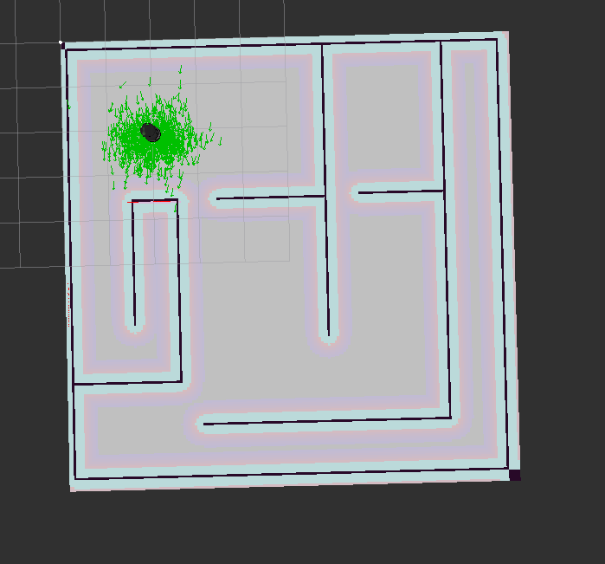

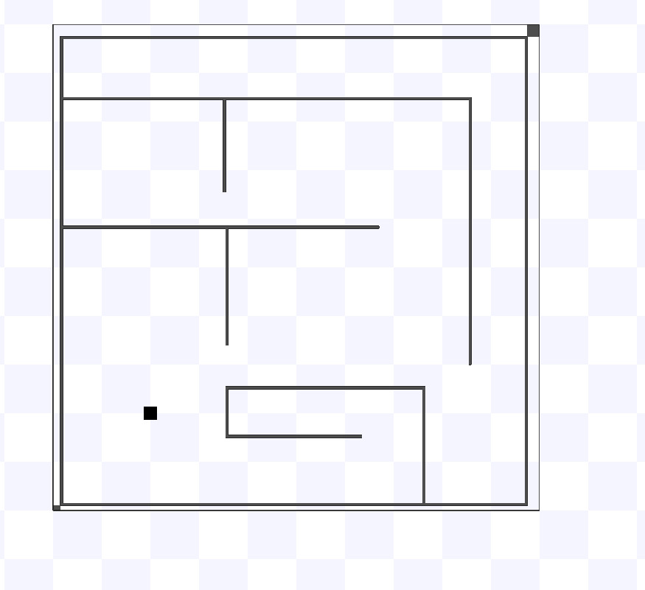

In another terminat open the teleop keyboard



source ./devel/setup.bash

roslaunch turtlebot_teleop keyboard_teleop.launch

